Class 1 (22.7%): N = 0.1 epochs = 5

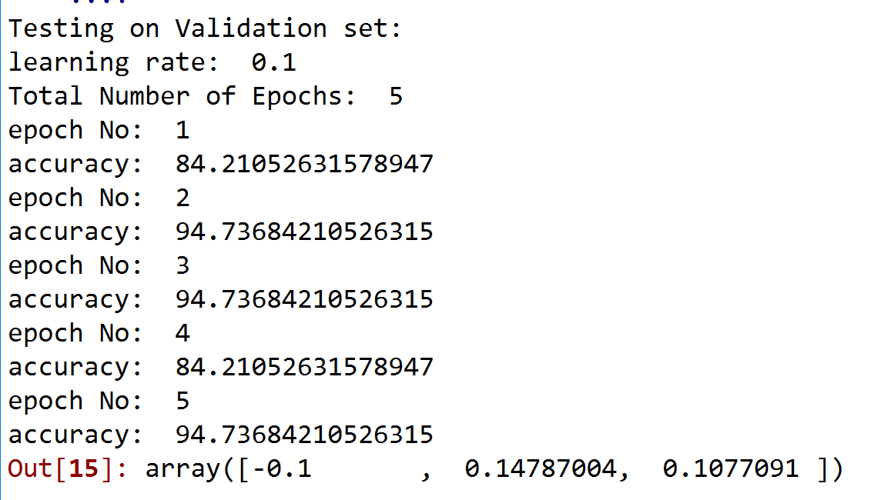

Average accuracy = 90.522%

N=0.2

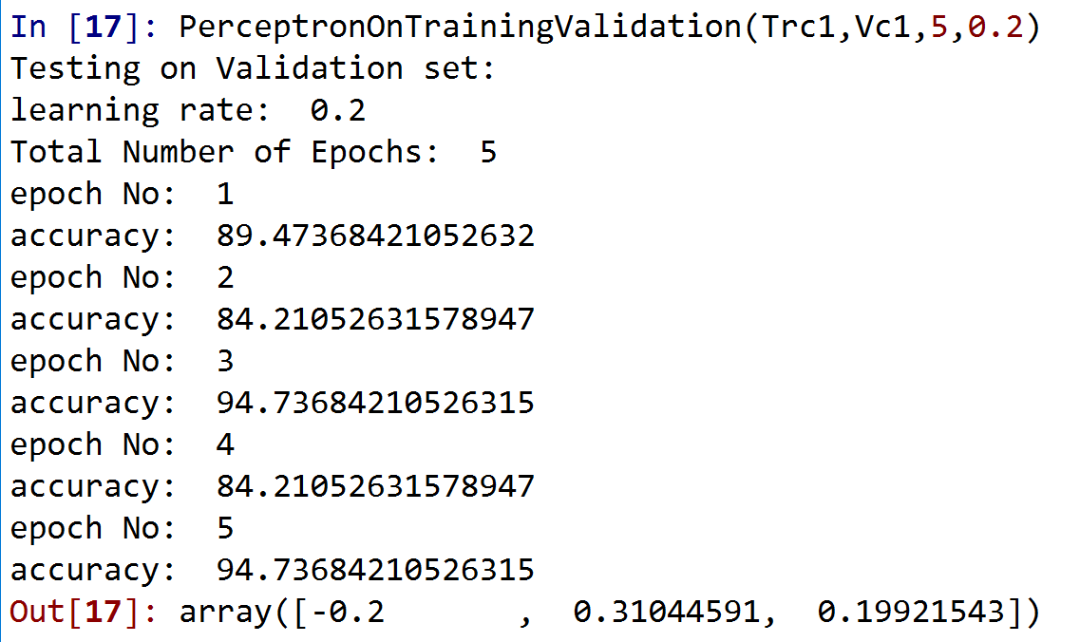

Average accuracy = 89.47%

N=0.3

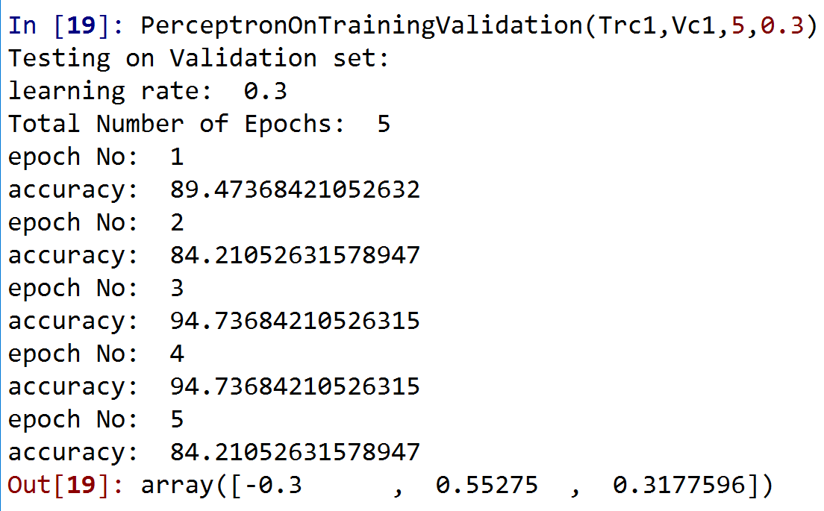

Average accuracy = 89.47%

N=0.4

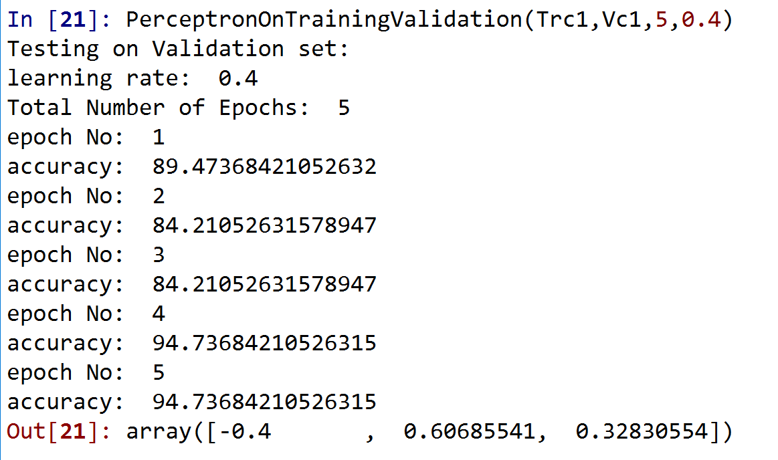

Average accuracy = 89.47%

N=0.5

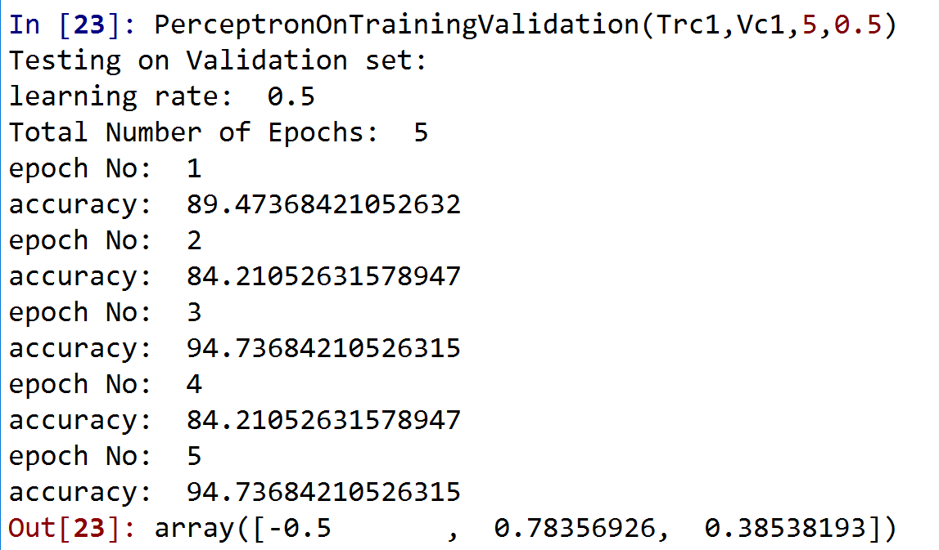

Average accuracy = 89.47%

Class 1 Optimal data:

Learning rate: 0.1

Class 2 (45%): N=0.1 epochs = 5

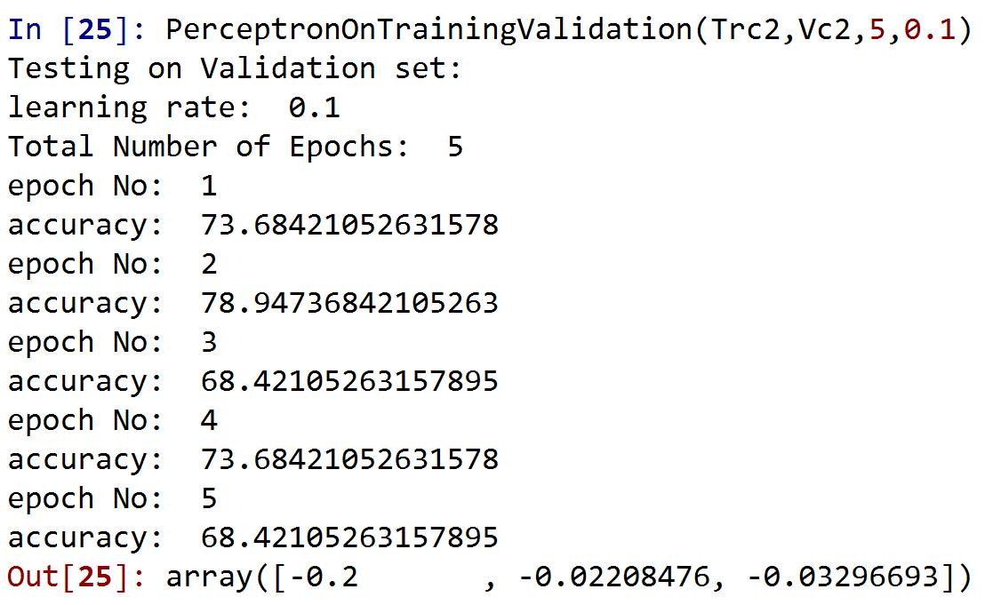

Average accuracy = 72.628%

N=0.2

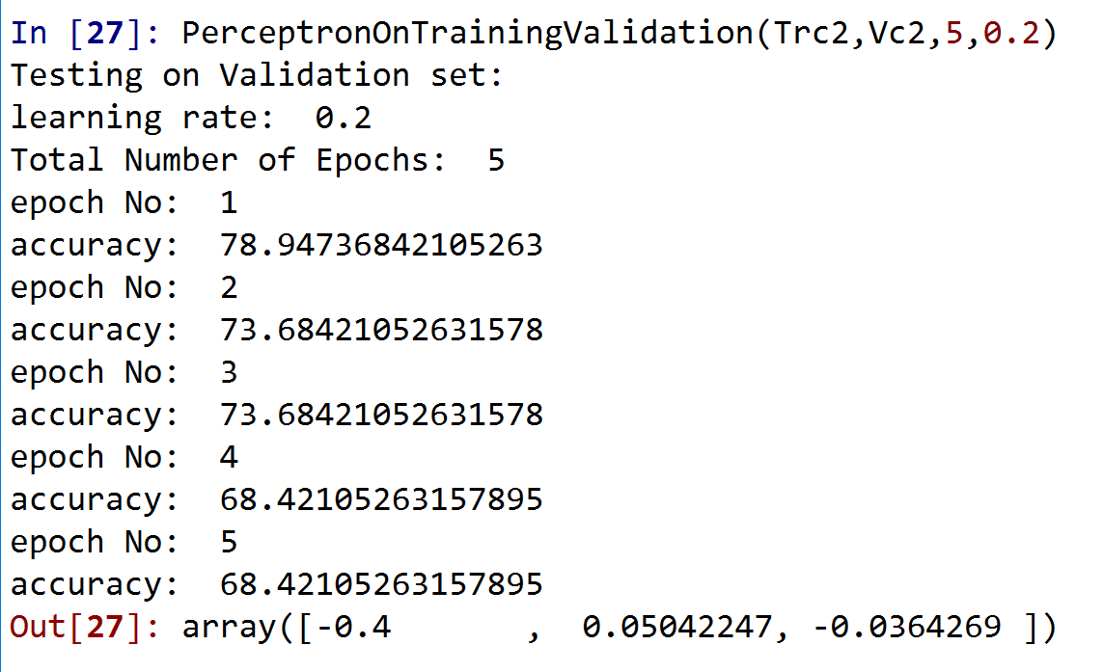

Average accuracy = 72.628%

N=0.3

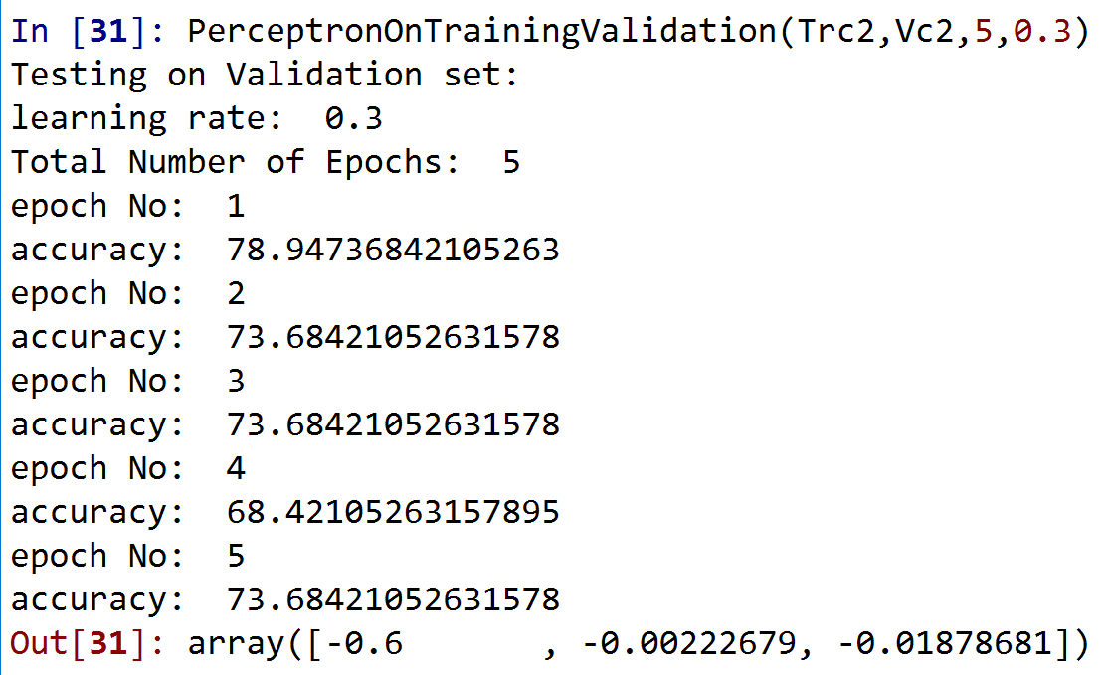

Average accuracy = 73.68%

N=0.4

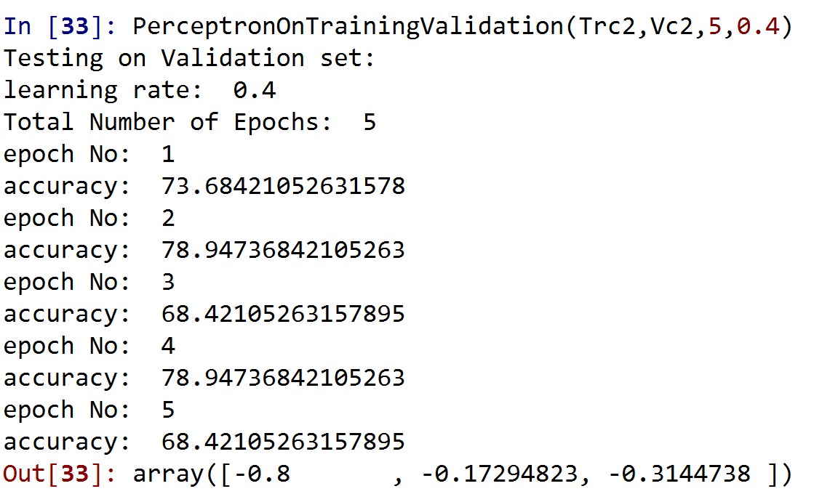

Average accuracy = 73.68%

N=0.5

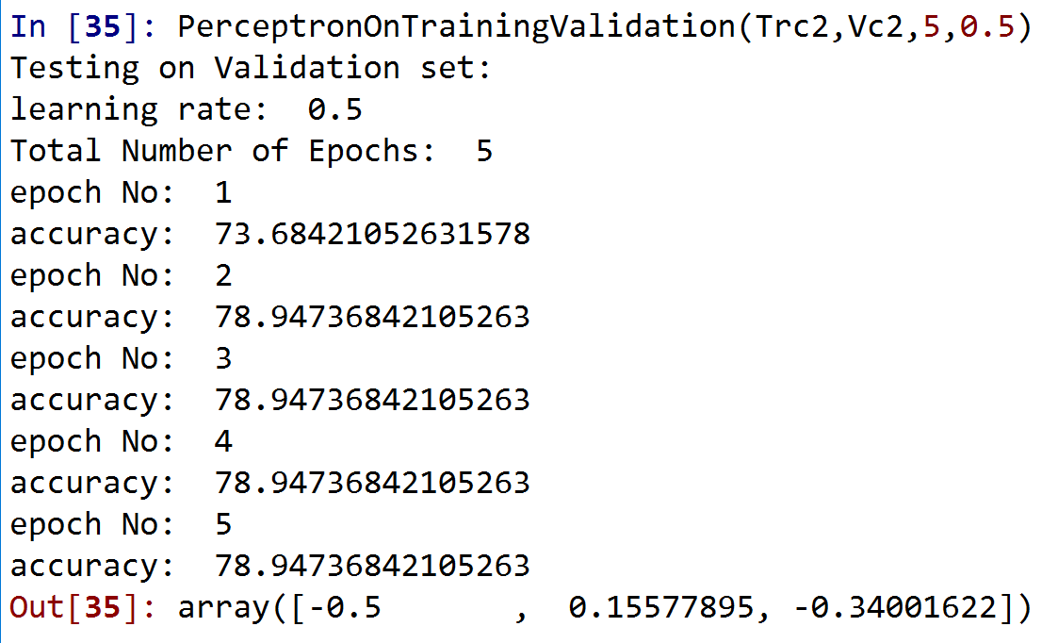

Average accuracy = 77.888%

Class Optimal data:

Learning Rate: 0.5

Class 3 (18%): N=0.1 epochs = 5

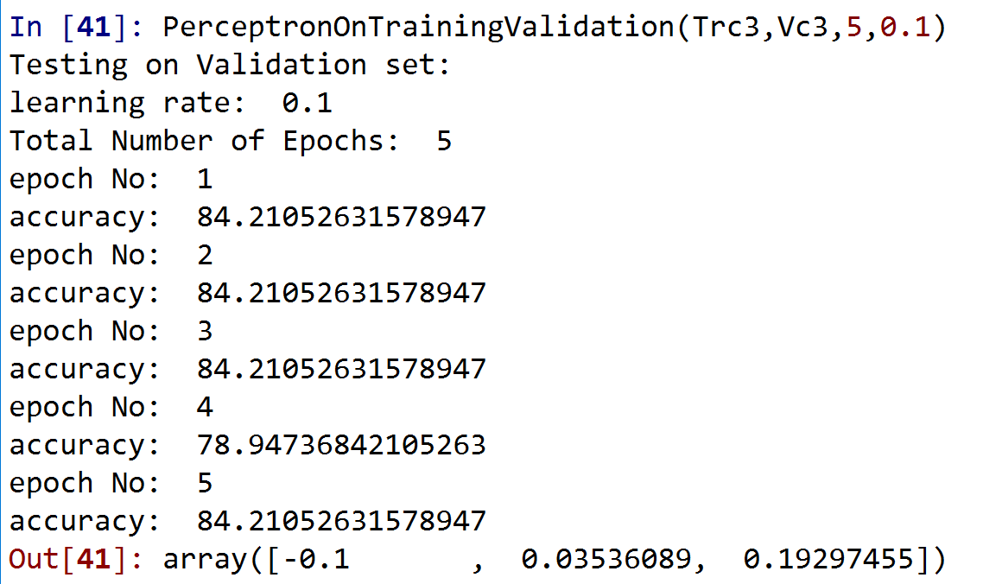

Average accuracy = 83.156%

N=0.2

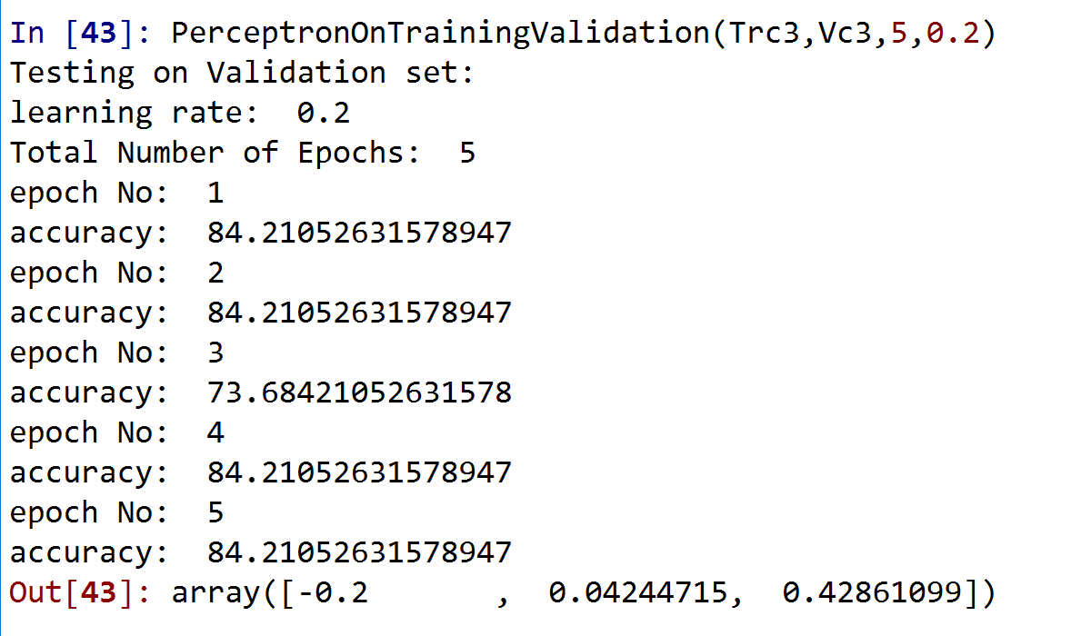

Average accuracy = 82.104%

N=0.3

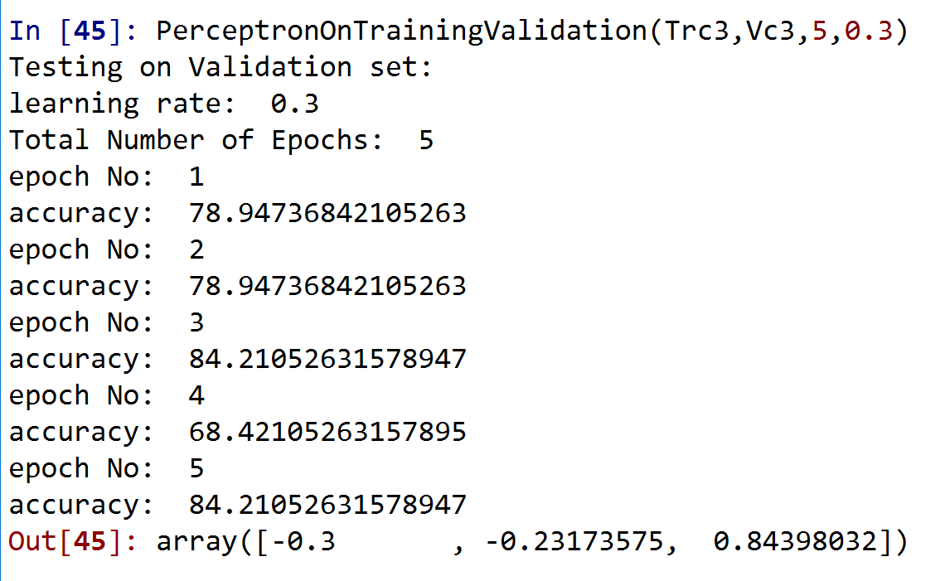

Average accuracy = 78.944%

N=0.4

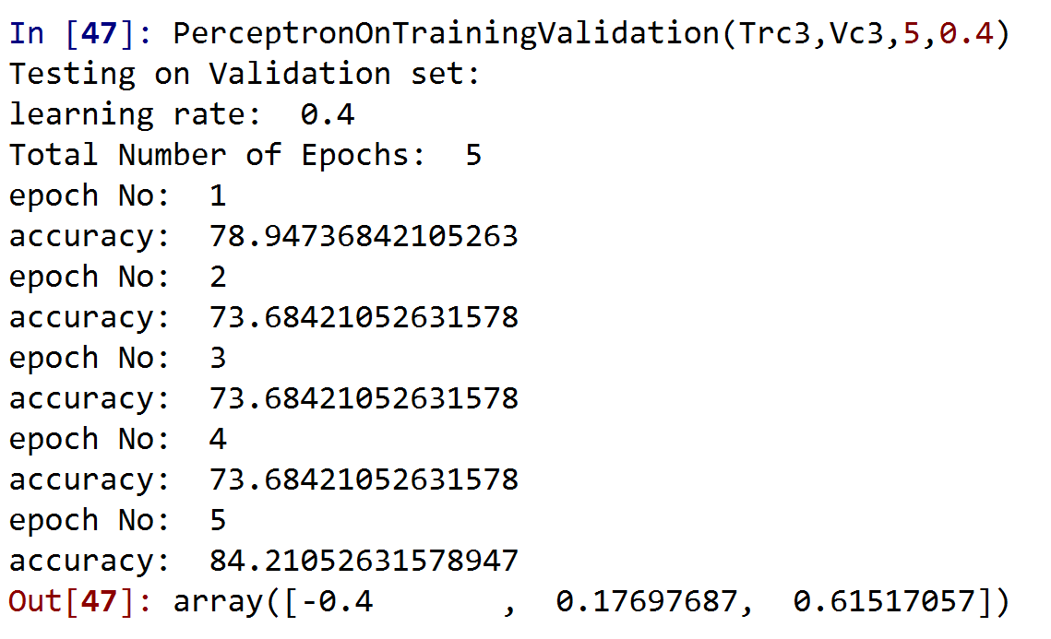

Average accuracy = 76.838%

N=0.5

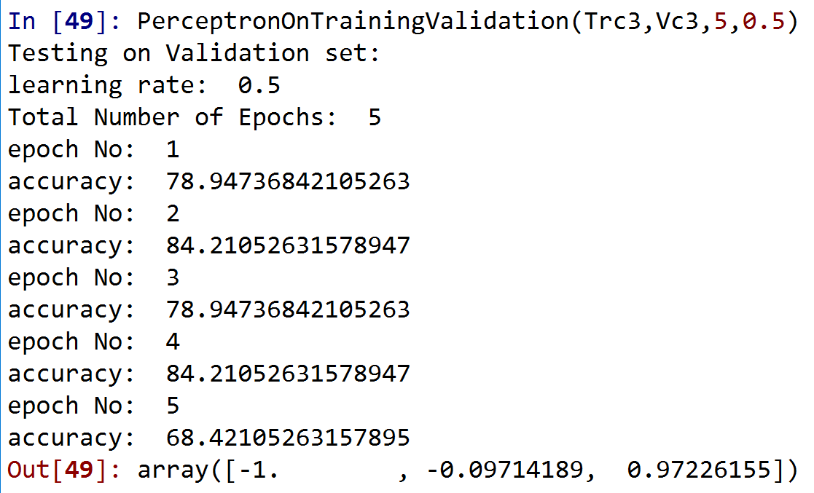

Average accuracy = 78.944%

Class Optimal data:

Learning rate: 0.1

Class 4(9%): N=0.1 epochs=5

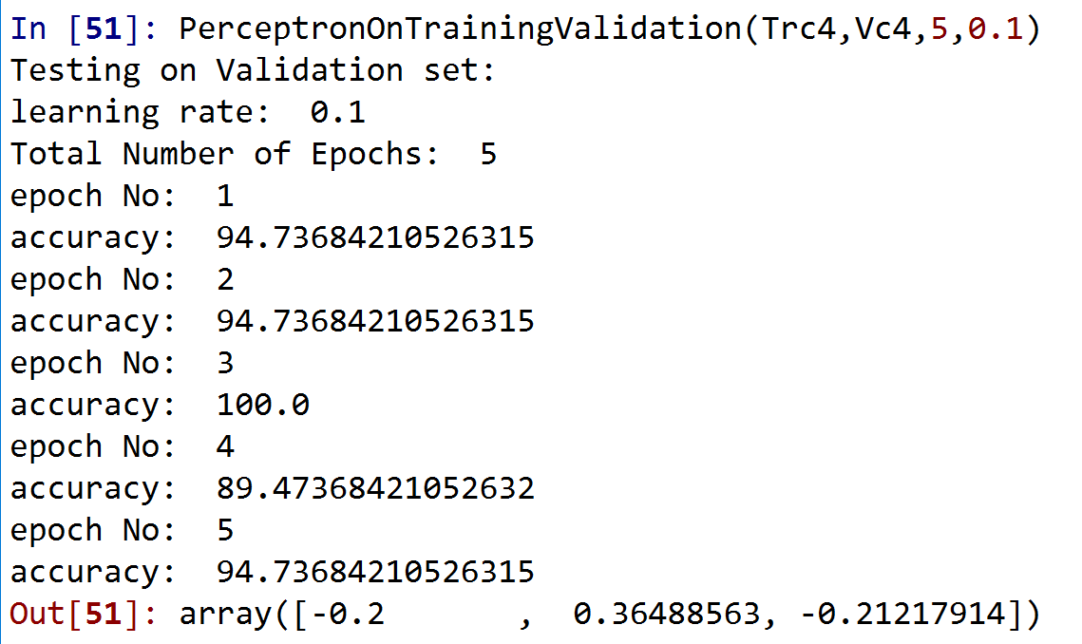

Average accuracy = 94.732%

N=0.2

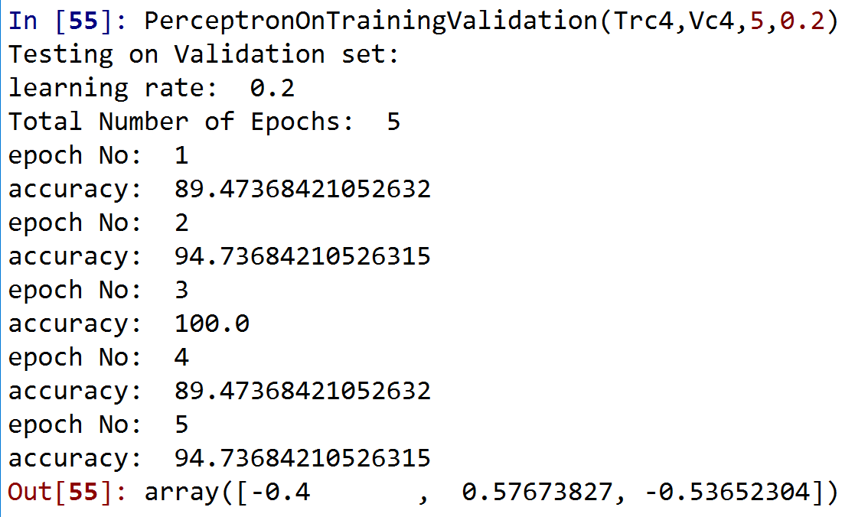

Average accuracy = 93.68%

N=0.3

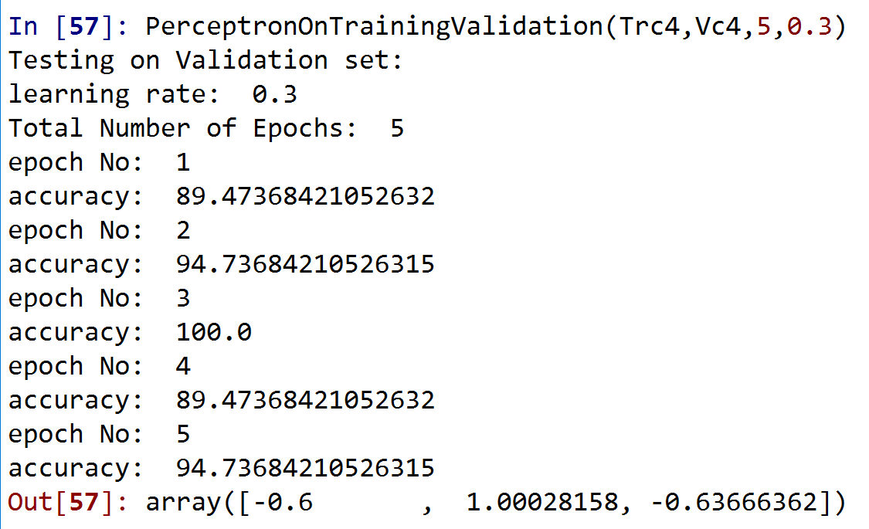

Average accuracy = 93.68%

N=0.4

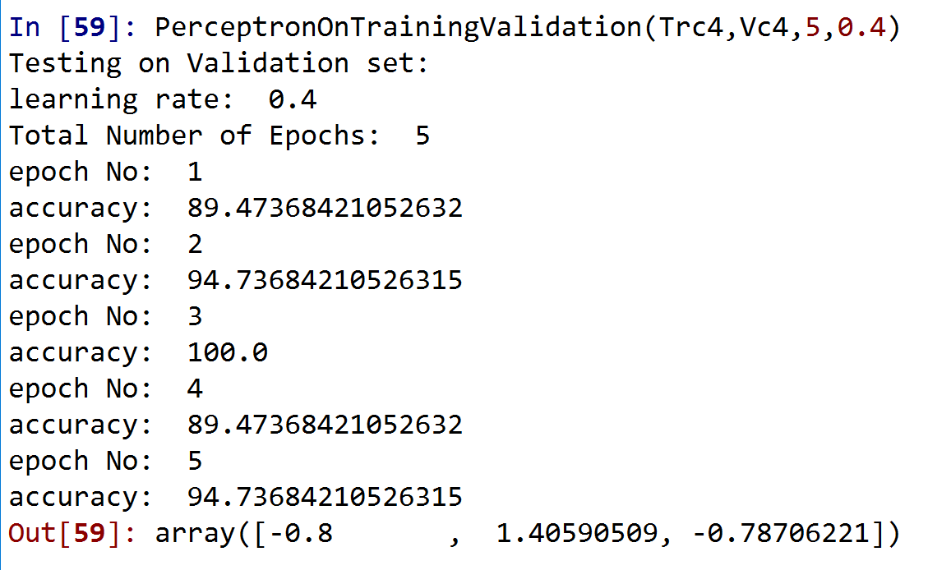

Average accuracy = 93.68%

N=0.5

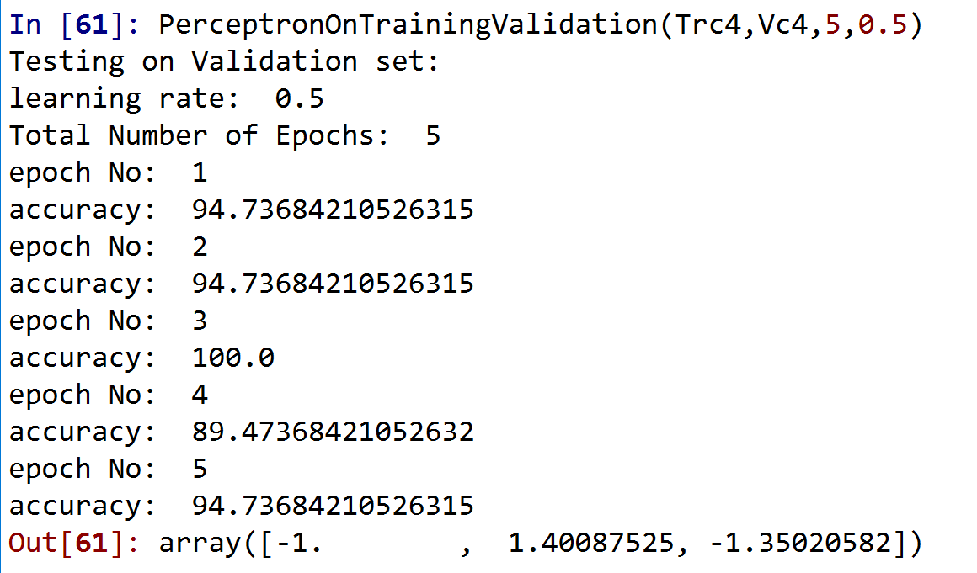

Average accuracy = 94.732%

Class optimal data:

We have two learning rates with maximum accuracy so we are going to pick one. In here we chose n=0.1

Class 5(4.5%): N=0.1 epochs=5

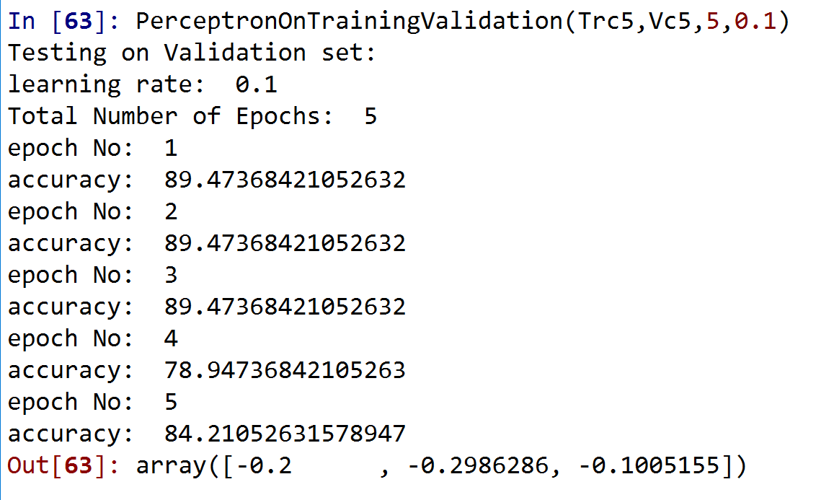

Average accuracy = 86.312%

N=0.2

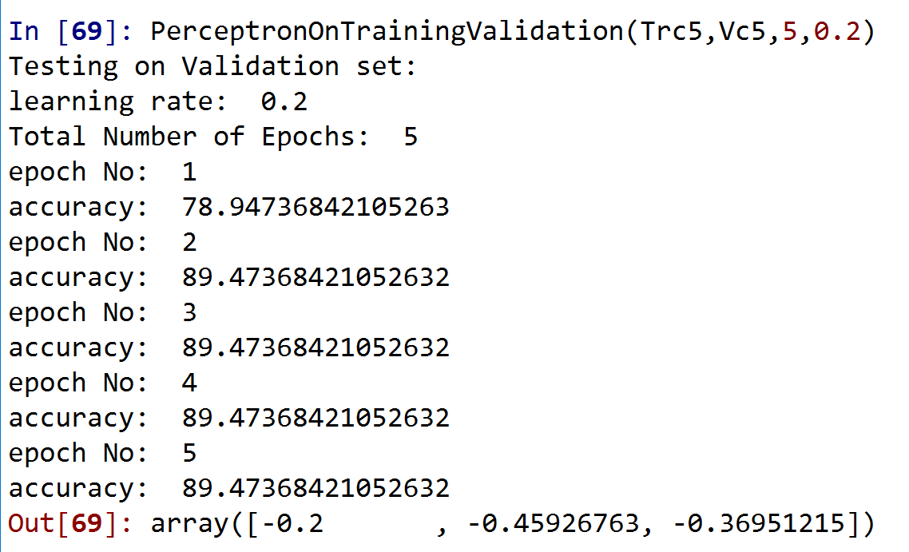

Average accuracy = 87.364%

N=0.3

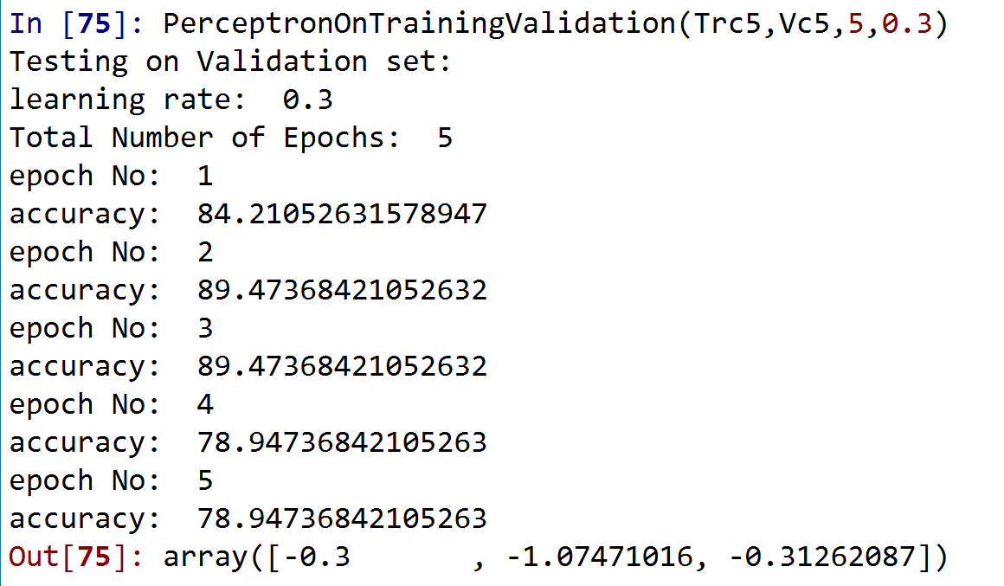

Average accuracy = 84.206%

N=0.4

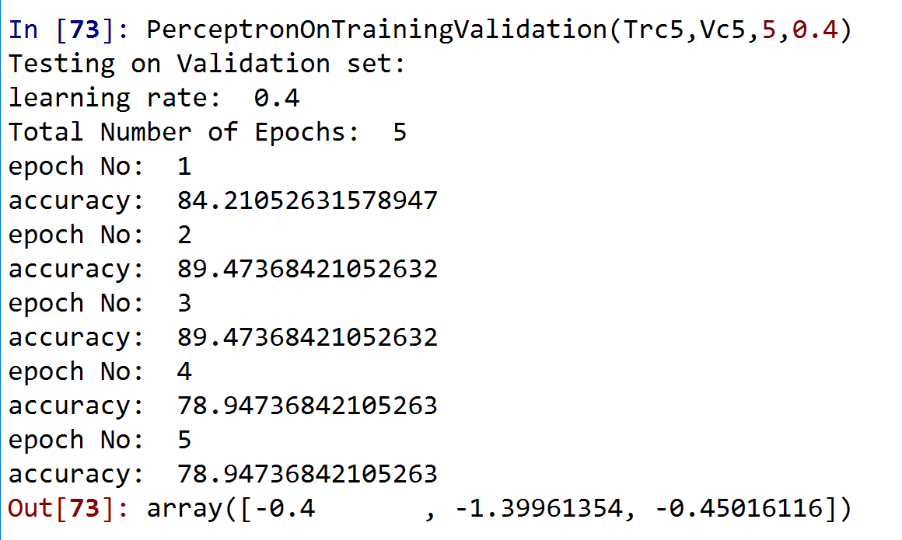

Average accuracy = 84.206%

N=0.5

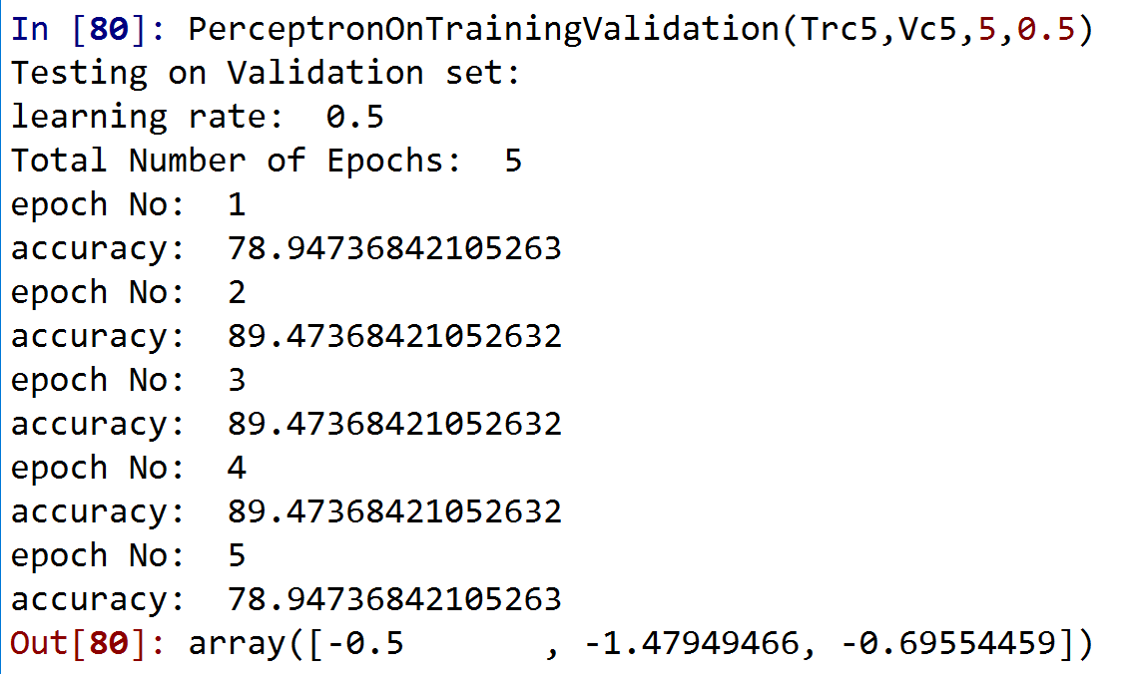

Average accuracy = 85.258%

Class 4 optimal data:

Learning rate = 0.2

All class optimal epochs: